Secured Medical Records Using Blockchain

Darshan Patel (18IT079), Jay Patel (18IT088)

***Abstract*—iNowadaysimanyiorganizationsiusesicloudicompu-itingiinihealthiinformationimanagementiworldwide.iByithis,ime-idicalitranscriptionipricingiisibeingireduced.iDespiteitheibenefitsioficloudicomputing,itheiissuesiareialsoiveryiimmense.That’siwhyiblockchainitechnologyiisiintroduceditoimakeisystemimoreieffici-ientiandimoreisecured.iThisiisiaiBlockchainibasediprojectiiniwhichitheipatient’simedicalihistoryiisimaintained.iHereitheientitiesiareidoctor,ipatientiandichemist.iTheichemistihasionlyirightitoiviewitheimedicineilistiandidoctoricaniviewiandiappendifurtherimedicalirecordsiofipatient.iTheitransactioniisithereibetweenipatientiandichemistiforitheipurchasedimedicinesithroughismarticontractiusingicryptocurrency.**

# SYSTEM REQUIREMENT

1. *User characteristics:*

User: Run the code and use functionalities.

1. *Hardware and software requirements:*
   1. *Remix IDE:*

RemixiisiaibrowseribasedicompileriandiIDEithatienablesiEthereumicontractsiwithisolidityilanguageitoidebugitransacti-ions.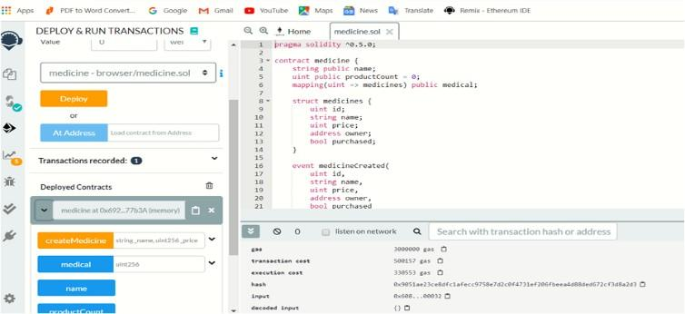

* + 1. **INTRODUCTION**

1. *Project summary:*

The Secured Medical System is a Blockchain based project. Here we have taen 3 entities ie Doctor, Patient and Chemist. Here the doctor will upload data into the blockchain. The same data by patient id will be accessible by the chemist. This will establish trust between patients, doctor and chemist.

1. *Purpose:*

This type of system already exist but as it uses cloud compu- ting, it is less secured. Despite the benefits of cloud computing, the issues are also very immense. It is reported that data privacy is a concern for the utilization of cloud computing in the health- care industry. Cloud computing can cause poor encryption key management because it is a multi-tendency management sys- tem. That’s why blockchain technology is employed to make system more efficient and more secured.

1. *Scope:*

The scope is to build trust between patient, doctor and chemist and for easy access and transaction. To maintain transparency between all 3 entities.

1. *Technology:*

In order to build the project we used the Ethereum blockchain where transactions are done by exchanging ethers. Here we have implemented smart contracts which are the building blocks of thatiweiuseitoicreateiblockchainiapplications.

* + 1. **OBJECTIVE**

ThisiisiaiBlockchainibasediprojectiiniwhichitheipatient’sime-idicalihistoryiisimaintained.iHereitheientitiesiareidoctor,ipatientiandichemist.iTheichemistihasionlyitheirightitoiviewitheime-idicineilistianditheidoctoricaniviewiandiappendifurtherimedicalirecordsiofitheipatient.iTheitransactioniisithereibetweenipatientiandichemistiforitheipurchasedimedicinesithroughismarticontractiusingicryptocurrency.

* 1. *Metamask:*

Metamaskiisiaibridgeithatiallowsiyouitoivisititheidistributediwebiofitomorrowiiniyouribrowseritoday.iItiallowsiyouitoiruniEthereumiAppsirightiiniyouribrowseriwithoutiaifulliEthereuminode.iMetamaskiisiaibrowseriextensionicurrentlyiavailableioniallitheithreeimajoribrowsers(chrome,firefox,opera).

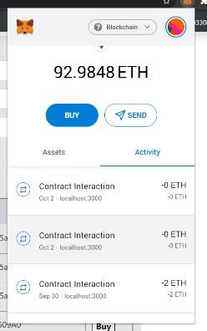 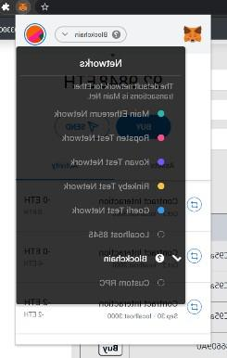

* 1. *Ganache:*

GanacheiisiusediforisettingiupiaipersonaliEthereumiblockchainiforitestingisolidityicontracts.iItisimulatesitheifeaturesiofirealiEthereuminetworki,iincludingitheiavailabilityiofiainumberiofiaccountsifundediwithitestiether.

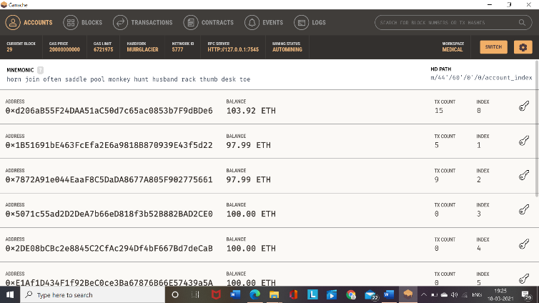 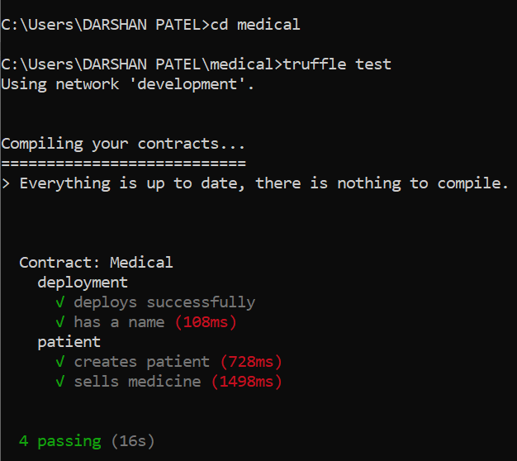

* 1. *Node.JS:*

Itiisianiopenisourcei,icrossiplatformiruntimeienvironmentiforiserverisideiandinetworkiapplicationi.iNode.jsiapplicationsiareiwritteniiniJavaScript,iandicanibeiruniwithinitheiNode.jsiruntimeioniOS,iMicrosof

# METHODOLOGY

1. *Creatingismarticontract:*

Here,iweiuseditoicreateiaismarticontractiwhichiisilikeiailegalicontractiusediinibusiness.iTheseismarticontractsiareiconsiderediasiaibuildingiblockiofiblockchainitechnology.iItiisidevelopediinisolidityilanguage(influencedibyiC++,iPythoniandiJavaScriptiandiisidesigneditoitargetitheiEthereumiVirtualiMachine).iItiincludesioverallilogiciandifunctionsiofieachientityiconsiderediiniaiblockchain.iItiisicompilediusingifollowingicommand:itruffleicompile

1. *Deployingitheismarticontract:*

After building a smart contract, it is migrated and deply- ed to a personal blockchain provided by ganache (personal blockchain for rapid Ethereum and Corda distributed applic- ation development) using truffle framework(a development environment, testing framework and asset pipeline for Ethereum).

This is done by following commands: truffle migrate

1. *Testing:*

Afterideployingitheismarticontractiweihaveitoicreateiaitestifileiforitestingiourismarticontracticonsideringiallipossi-ibilitiesisoithatiweicanisaveitheigasiusediinitheitransactioniifitheitransactionifailsiusingiexceptionihandlingiconcepts.

Commandiforitesting:itruffleitest

1. *Compilingiproject:*

Hereiisitheicmdioutputiwhichishowsisomeibasicioperat-iionsilikeideploysisuccessfullyi,inameigiveni,ipatienticreatediandimedicineisold

1. *Doingimigration*

When we compile truffle migrate commands in cmd it’s provide some information related Network name , Network id

, Block gas limit ,transaction hash ,gas used, gas price, val-ue sent and total cost.

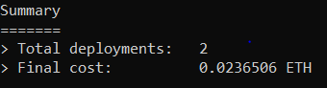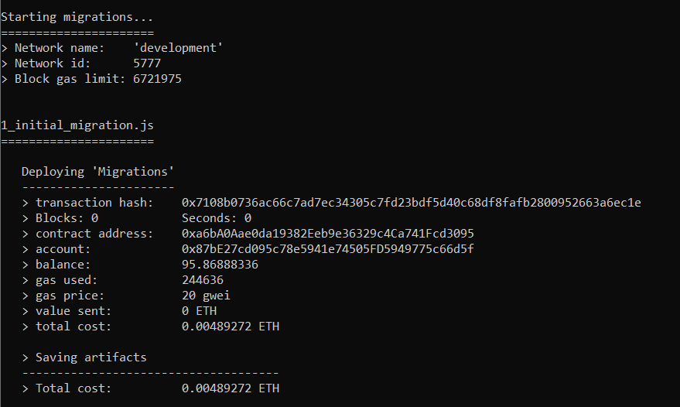

Herei,iiniblockchainigasiisibasicallyipricingivalueiitimeansirequireditoisuccessfullyiexecuteiaismarticontractionitheiEthereumiblockchainiplatform.iIfigasivalueidoesinotimatchitheirithresholditransactioniwouldibeideclined.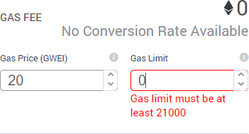

# DATAiFLOWiDIAGRAM

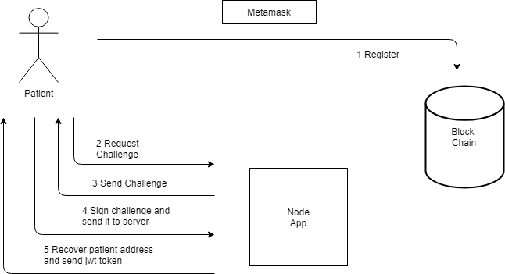

1. **FEATURES**

Theidataistructureiiniaiblockchainiisiappend-only.

So,itheidataicannotibeialterediorideleted.iEnhancedisecurity.

Traditionaliprocessiofimaintainingirecordsiinifilesiisieliminated.

Theimedicalihistoryiofiaipersoniisieasilyimaintainediandialsoitheipricingirecordiofimedicineiisimaintained.

# OUTPUTS

Byipassinginpmirunistarticommandiourismarticontractiwouldidirectlyire-directediatilocalihosti:i3000iwhereismarticontractiisilinkediwithiganacheiandimatamask.

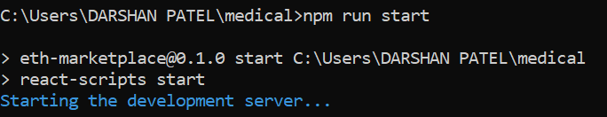

Theiuserifriendlyiinterfaceiwhereichemistihasionlyirightitoiviewitheimedicineilistiandidoctoricaniviewiandiappendifurtherimedicalirecordsiofipatient.

# CONCLUSION

IiconcludeimyiSGPibyithisithatiiicameiacrossiainewitechnologyiieiBlockchainiandiiiindeedibecomeiawareiaboutitheiwayiblockchainisystemiworks,ieffectivenessithatiitiprovi-idesiinisecurityiandialsoiaboutitheiwayithatiiticanibeihelpfuliforianyitransactionsibyicreatingiouriownicurrencyiieicryptocurrency

# REFERENCES

* 1. [**https://medium.com/@sukantkhurana/blockcihain-for-medical-records-4efbf625b6d4**](https://medium.com/%40sukantkhurana/blockchain-for-medical-records-4efbf625b6d4)
  2. [**https://solidity.readthedocs.io/en/develop/conitracts.html**](https://solidity.readthedocs.io/en/develop/contracts.html)
  3. [**https://medium.com/cryptoxtech/erc20-token-istandard-a-beginners-guide-5b5f0c87e11f**](https://medium.com/cryptoxtech/erc20-token-standard-a-beginners-guide-5b5f0c87e11f)

